24th January 2018

**YOKOHAMA Develops the World’s Largest Floating Fender, and Contributes to Safer Cargo Loading**

YOKOHAMA has developed the world’s largest floating pneumatic rubber fender, with a diameter of six meters in December 2017. The fender is designed to be used at offshore cargo transfer operations of liquefied natural gas (LNG) from LNG-FPSO (Floating Production, Storage and Offloading system) to LNG tankers.  
  
Demand for LNG-FPSO is expected to increase as demand for LNG rises. LNG-FPSO must be capable of efficiently and safely offloading LNG stored at a temperature of around −160℃ to LNG tankers. YOKOHAMA's newly developed ultra-large fender increases the safety of offloading operations by enabling the LNG-FPSO and the LNG tanker to maintain a greater distance apart than that with previously existing fenders. The new fender is also expected to be used in enhancing safety during construction of large marine structures and other offshore construction work.  
  
The pneumatic fender is a rubber cushioning product inflated with air and floated between two ships or between a ship and a quay wall for the purpose of preventing damage to the hull and the quay wall during ship-to-ship operations or when ships are moored.   
  
YOKOHAMA is one of the world's leading manufacturers of pneumatic fenders, marine hoses and other products for the marine equipment market. YOKOHAMA was the world’s first company to manufacture and sell rubber-based pneumatic marine fenders. Since their launch in 1958, these products have become essential to at-sea ship-to-ship transfers of crude oil, LPG, and other crucial cargo.

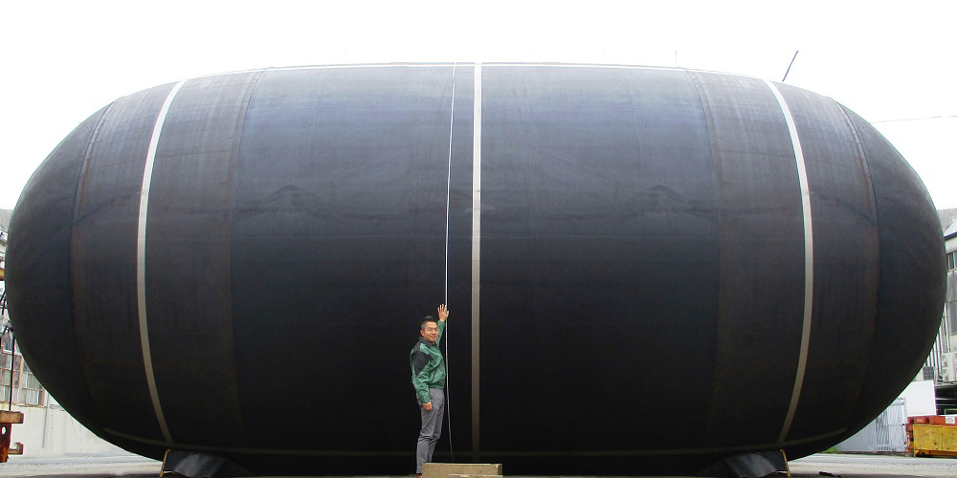

*Ultra-large fender with 6m diameter*